this keyword in java

There can be a lot of usage of **java this keyword**. In java, this is a **reference variable** that refers to the current object.

Usage of java this keyword

Here is given the 6 usage of java this keyword.

1. this can be used to refer current class instance variable.
2. this can be used to invoke current class method (implicitly)
3. this() can be used to invoke current class constructor.

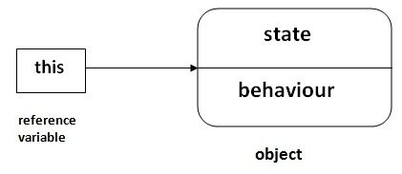

### 1) this: to refer current class instance variable

The this keyword can be used to refer current class instance variable. If there is ambiguity between the instance variables and parameters, this keyword resolves the problem of ambiguity.

#### Understanding the problem without this keyword

|  |
| --- |
| Let's understand the problem if we don't use this keyword by the example given below: |

1. **class** Student{
2. **int** rollno;
3. String name;
4. **float** fee;
5. Student(**int** rollno,String name,**float** fee){
6. rollno=rollno;
7. name=name;
8. fee=fee;
9. }
10. **void** display(){System.out.println(rollno+" "+name+" "+fee);}
11. }
12. **class** TestThis1{
13. **public** **static** **void** main(String args[]){
14. Student s1=**new** Student(111,"ankit",5000f);
15. Student s2=**new** Student(112,"sumit",6000f);
16. s1.display();
17. s2.display();
18. }}

Output:

0 null 0.0

0 null 0.0

In the above example, parameters (formal arguments) and instance variables are same. So, we are using this keyword to distinguish local variable and instance variable.

#### Solution of the above problem by this keyword

1. **class** Student{
2. **int** rollno;
3. String name;
4. **float** fee;
5. Student(**int** rollno,String name,**float** fee){
6. **this**.rollno=rollno;
7. **this**.name=name;
8. **this**.fee=fee;
9. }
10. **void** display(){System.out.println(rollno+" "+name+" "+fee);}
11. }
13. **class** TestThis2{
14. **public** **static** **void** main(String args[]){
15. Student s1=**new** Student(111,"ankit",5000f);
16. Student s2=**new** Student(112,"sumit",6000f);
17. s1.display();
18. s2.display();
19. }}

Output:

111 ankit 5000

112 sumit 6000

If local variables(formal arguments) and instance variables are different, there is no need to use this keyword like in the following program:

#### Program where this keyword is not required

1. **class** Student{
2. **int** rollno;
3. String name;
4. **float** fee;
5. Student(**int** r,String n,**float** f){
6. rollno=r;
7. name=n;
8. fee=f;
9. }
10. **void** display(){System.out.println(rollno+" "+name+" "+fee);}
11. }
13. **class** TestThis3{
14. **public** **static** **void** main(String args[]){
15. Student s1=**new** Student(111,"ankit",5000f);
16. Student s2=**new** Student(112,"sumit",6000f);
17. s1.display();
18. s2.display();
19. }}

Output:

111 ankit 5000

112 sumit 6000

#### It is better approach to use meaningful names for variables. So we use same name for instance variables and parameters in real time, and always use this keyword.

### 2) this: to invoke current class method

You may invoke the method of the current class by using the this keyword. If you don't use the this keyword, compiler automatically adds this keyword while invoking the method. Let's see the example

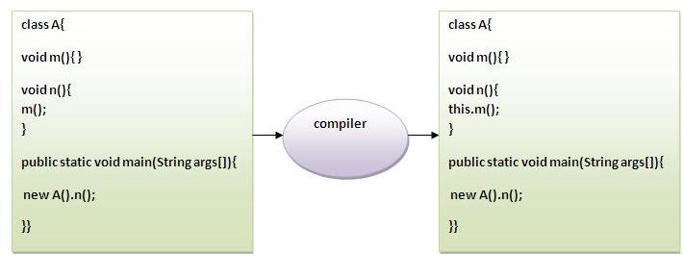

1. **class** A{
2. **void** m(){System.out.println("hello m");}
3. **void** n(){
4. System.out.println("hello n");
5. //m();//same as this.m()
6. **this**.m();
7. }
8. }
9. **class** TestThis4{
10. **public** **static** **void** main(String args[]){
11. A a=**new** A();
12. a.n();
13. }}

Output:

hello n

hello m

### 3) this() : to invoke current class constructor

The this() constructor call can be used to invoke the current class constructor. It is used to reuse the constructor. In other words, it is used for constructor chaining.

**Calling default constructor from parameterized constructor:**

1. **class** A{
2. A(){System.out.println("hello a");}
3. A(**int** x){
4. **this**();
5. System.out.println(x);
6. }
7. }
8. **class** TestThis5{
9. **public** **static** **void** main(String args[]){
10. A a=**new** A(10);
11. }}

Output:

hello a

10

**Calling parameterized constructor from default constructor:**

1. **class** A{
2. A(){
3. **this**(5);
4. System.out.println("hello a");
5. }
6. A(**int** x){
7. System.out.println(x);
8. }
9. }
10. **class** TestThis6{
11. **public** **static** **void** main(String args[]){
12. A a=**new** A();
13. }}

Output:

5

hello a

### Real usage of this() constructor call

The this() constructor call should be used to reuse the constructor from the constructor. It maintains the chain between the constructors i.e. it is used for constructor chaining. Let's see the example given below that displays the actual use of this keyword.

1. **class** Student{
2. **int** rollno;
3. String name,course;
4. **float** fee;
5. Student(**int** rollno,String name,String course){
6. **this**.rollno=rollno;
7. **this**.name=name;
8. **this**.course=course;
9. }
10. Student(**int** rollno,String name,String course,**float** fee){
11. **this**(rollno,name,course);//reusing constructor
12. **this**.fee=fee;
13. }
14. **void** display(){System.out.println(rollno+" "+name+" "+course+" "+fee);}
15. }
16. **class** TestThis7{
17. **public** **static** **void** main(String args[]){
18. Student s1=**new** Student(111,"ankit","java");
19. Student s2=**new** Student(112,"sumit","java",6000f);
20. s1.display();
21. s2.display();
22. }}

Output:

111 ankit java null

112 sumit java 6000

#### Rule: Call to this() must be the first statement in constructor.

1. **class** Student{
2. **int** rollno;
3. String name,course;
4. **float** fee;
5. Student(**int** rollno,String name,String course){
6. **this**.rollno=rollno;
7. **this**.name=name;
8. **this**.course=course;
9. }
10. Student(**int** rollno,String name,String course,**float** fee){
11. **this**.fee=fee;
12. **this**(rollno,name,course);//C.T.Error
13. }
14. **void** display(){System.out.println(rollno+" "+name+" "+course+" "+fee);}
15. }
16. **class** TestThis8{
17. **public** **static** **void** main(String args[]){
18. Student s1=**new** Student(111,"ankit","java");
19. Student s2=**new** Student(112,"sumit","java",6000f);
20. s1.display();
21. s2.display();
22. }}

Compile Time Error: Call to this must be first statement in constructor